**PREDICTIVE ANALYTICS IN SOCIAL MEDIA – FORECASTING CONSUMER BEHAVIOUR AND MARKET TRENDS**

**ABSTRACT**

Consumer-brand interactions have been transformed by social media, which provides an unparalleled amount of user-generated data that is essential for strategic decision-making. Using data from social media, this study examines how predictive analytics might be used to decipher customer behaviour and predict market trends. The study examines twitter datasets from top brands, including Zara, H&M, Gap, and Uniqlo, from 2017 to 2023 with an emphasis on the fashion sector. The study assesses the efficacy of several sophisticated machine learning models, including Random Forest, Support Vector Machines (SVM), Long Short-Term Memory (LSTM), and Bidirectional Encoder Representations from Transformers (BERT), in handling both structured and unstructured data, in identifying sequential patterns, and in conducting sentiment analysis. To prepare a variety of datasets for analysis, the methodology incorporates thorough data pretreatment techniques including tokenisation and vectorisation. SVM has strong sentiment categorisation, while Random Forest is excellent at managing structured data and detecting important engagement drivers. While BERT's bidirectional capabilities offer subtle insights into customer emotion and intent, LSTM efficiently models temporal relationships, facilitating trend analysis and forecasting. The results provide useful suggestions for marketing tactics by demonstrating the substantial impact that media-rich postings and the best times to post have on customer engagement. Advanced optimisation approaches are used to solve issues like as overfitting, processing demands, and data imbalance. This study demonstrates how predictive analytics may improve digital marketing strategies and facilitate data-driven decision-making by bridging the gap between raw social media data and actionable insights. In order to improve forecasting accuracy and increase industry applicability, future research will examine hybrid model architectures and real-time analytics. The revolutionary potential of incorporating predictive analytics into social media marketing is highlighted by this study, opening the door for improved customer interaction and company expansion.

**Acknowledgements**

**TABLE OF CONTENTS**

1. Introduction 5

1.1. Problem Statement 5

1.2. Project Rationale 6

1.3. Project Scope 7

1.4. Project Aim 7

1.5. Project Objectives 7

1.6. Research Question 8

1.7. Achieving the Research Objectives 8

1.8. Project Benefits 9

1.9. Beneficiaries 9

2. Literature Review 10

2.1. Historical Perspective on Social Media Marketing 10

2.2. Current Trends in Social Media Marketing 10

2.3. Existing Solutions Enabled by Machine Learning 11

2.4. Application of Machine Learning in Social Media Marketing 13

2.5. Understanding predictive analytics 14

2.6. Identifying business expansion opportunities 15

2.7. Enhancing profitability through predictive analytics 17

2.8. Implementing data-driven strategies for business expansion 18

2.9. Literature Gap 19

3. Methodology 20

3.1. Research Design 21

3.1.1. Research Philosophy 21

3.1.2. Research Approach 21

3.1.3. Research Strategy 21

3.1.4. Research Choice 22

3.1.5. Time Horizon 22

3.2. Tools and Techniques 23

3.3. Models and Methods 25

3.3.1. Random Forests 25

3.3.2. SVM 25

3.3.3. LSTM 26

3.3.4. BERT 26

3.4. Ethical Considerations 27

4. Data Analysis 28

4.1. Data Collection 28

4.2. Data Preprocessing 29

4.3. Interpretation of graphical trends 32

4.3.1. Distribution of Numerical Features 32

4.3.2. Tweet Distribution by company 33

4.3.3. Tweets with Text vs Without 33

4.3.4. Correlation Matrix 34

4.3.5. Top 10 Used Hashtags 34

4.3.6. Media Usage in Tweets 35

4.3.7. Engagement by Media Type 35

4.3.8. Likes Over Time 36

4.3.9. Likes by Hour of the Day 36

5. Model Selection and Development 37

5.1. Criteria for Model Selection 37

5.2. Model Development 38

5.2.1. Random Forest 38

5.2.2. Support Vector Machines (SVM) 39

5.2.3. Long Short-Term Memory (LTSM) 39

5.2.4. BERT (Bidirectional Encoder Representations from Transformers) 40

5.3. Model Integration 42

5.4. Evaluation Metrics 42

6. Discussion and results 42

6.1. Model Performance Analysis 43

6.1.1. Random Forest 43

6.1.2. Support Vector Machine 43

6.1.3. Long Short-Term Memory (LTSM) 43

6.1.4. Bidirectional Encoder Representations from Transformers (BERT) 44

6.2. Comparative Evaluation 44

6.3. Engagement Insights 44

6.4. Challenges Addressed 45

6.5. Key findings 45

7. Conclusion 46

8. References 47

**LIST OF FIGURES**

Figure 1 - Distribution by Numerical Features 35

Figure 2 - Tweet Distribution by Company 35

Figure 3 - Tweets with Text vs Without Text 36

Figure 4 - Correlation Matrix 36

Figure 5 - Top 10 used Hashtags 37

Figure 6 - Media Usage in Tweets 37

Figure 7 - Total Likes Over Time 38

Figure 8 - Likes by Hour of the Day 39

# Introduction

In order to understand consumer behaviour and anticipate market trends, businesses need to use predictive analytics. The rise of social media sites like Facebook, Instagram and X (formerly Twitter) has generated a vast amount of user-generated data which is an essential tool for decision-making in organisations. Advanced methods that can manage this data's scale, complexity and unstructured nature are needed to harness it (Hickins, 2023). With an emphasis on consumer behaviour and market trends in the fashion industry this study investigates how predictive analytics can be applied to social media to extract actionable insights. Deeper insights into these patterns can be obtained by utilising machine learning models like Random Forest, Support Vector Machines, BERT and Long Short-Term Memory. Text, photos and videos are just a few of the data types that these models can analyse to find trends and forecast future events (Mühlhoff, 2021). By using tweet datasets from fashion brands like Zara, H&M, Gap and Uniqlo this study aims to bridge the gap between strategic decision-making and raw social media data.

The importance of this study resides in its addition to the expanding corpus of research on marketing predictive analytics. Businesses are increasingly relying on data-driven tactics to stay competitive in dynamic marketplaces. However, problems like data integration, privacy concerns and the interpretability of machine learning models still persist. By tackling these issues with a careful analysis of predictive methods, businesses can make prompt, ethical decisions (Aldoseri, 2023). Along with evaluating the effectiveness of machine learning models this study offers recommendations for their practical use. Companies' flexibility and competitive edge should increase as a result of the findings which should help them better align their marketing strategies with consumer preferences. Through focussing on the interplay among social media, consumer behaviour and predictive analytics, this research aims to expand understanding of how digital insights can promote innovation in the fashion industry.

## Problem Statement

The quick growth of social media has resulted in a substantial amount of user-generated data that offers the valuable insights into consumer behaviour and market trends. Through social media sites like Facebook, Instagram and X (formerly Twitter) brands can communicate with their audiences and discover their preferences. However, obtaining useful insights from social media data is extremely difficult due to its unstructured and dynamic nature (Islam, 2024). The intricacies and non-linear patterns present in such data are frequently difficult for traditional analytical techniques to fully capture which reduces their usefulness for precise forecasting. Ineffective use of social media data may make it challenging for the fashion industry whose customer preferences are subject to rapid change, to make strategic decisions. It is crucial to identify trends, understand audience sentiment and predict consumer behaviour in order to align marketing strategies with consumer needs (Qi, 2023).

Existing research shows the potential of machine learning models in predictive analytics, but how well these models handle social media data in comparison is still lacking. By using advanced machine learning techniques like Random Forest, Support Vector Machines, Long Short-Term Memory and BERT this study seeks to address this challenge. These models have special advantages in textual insight extraction, time-series pattern recognition and processing both structured and unstructured data (Bajpai, 2023). In order to support data-driven decision-making in dynamic markets this research aims to determine the best model for predicting consumer behaviour and market trends by analysing tweet datasets from fashion brands like Zara, H&M, Gap and Uniqlo.

## Project Rationale

In the era of digital transformation, social media has become a crucial tool for businesses to engage with consumers and sustain competitiveness. Platforms like X (formerly Twitter) generate substantial real-time data that reflect consumer preferences, emerging trends and market dynamics. In the fashion industry, characterised by volatile consumer behaviour and swift trend changes, the capacity to analyse and forecast consumer behaviour through social media data is essential for success (Ramos, 2023). This highlights the necessity for sophisticated tools to derive actionable insights from the extensive and intricate datasets present on these platforms. Conventional data analysis techniques frequently inadequately address the intricacies and nuances of unstructured social media data, including text, images and videos. This constraint results in a deficiency in comprehending consumer sentiment, preferences and emerging trends (Giri, 2022).

Machine learning models, including Random Forest, SVM, LSTM and BERT offer sophisticated functionalities for analysing both structured and unstructured data rendering them suitable for this field. These models can distinguish complex patterns, recognise time-series trends and analyse textual sentiment providing a thorough methodology for predictive analytics (Konina, 2023). This project is especially relevant as enterprises increasingly depend on data-driven strategies to make informed decisions. This research seeks to connect raw data with strategic decision-making by utilising predictive analytics on social media data from prominent fashion brands, including H&M, Gap, Uniqlo and Zara. The insights produced will allow brands to adjust to market demands, refine marketing strategies and improve their competitive advantage in a swiftly changing digital marketplace.

## Project Scope

This study seeks to employ predictive analytics to forecast consumer behaviour and market trends using social media data, specifically from the X platform (formerly Twitter). The study concentrates on the fashion industry, analysing tweet datasets from four globally recognised brands such as H&M, Gap, Uniqlo and Zara. The datasets cover the period from 2017 to 2023, offering an extensive analysis of consumer engagement patterns, sentiments and trends over time. The study will utilise machine learning models such as Random Forest, Support Vector Machines, Long Short-Term Memory and BERT. These models are selected for their ability to analyse diverse data types including structured metrics (likes, retweets and hashtags) and unstructured textual content (tweet text and replies). The scope includes evaluating model performance using metrics such as recall, accuracy, precision and F1-score, thus enabling a thorough comparative analysis. The research encompasses data collection, preprocessing (including cleaning, tokenisation and normalisation) and the application of Natural Language Processing techniques to ready textual data for analysis. The emphasis is on social media datasets from fashion brands with the intention that the findings are applicable to other industries utilising predictive analytics. This research excludes the direct collection of consumer data opting instead for publicly available and anonymised social media datasets to comply with GDPR regulations (Doorn, 2018). The analysis focusses solely on the correlation between Twitter advertising and consumer behaviour excluding other social media platforms and offline consumer activities.

## Project Aim

The principal objective of this study is to establish a predictive framework that precisely anticipates consumer behaviour and market trends utilising social media data.

## Project Objectives

* To conduct a comprehensive literature review on the utilisation of machine learning for predictive analytics in forecasting market trends and consumer behaviour.
* To preprocess and analyse the social media dataset to guarantee data quality and appropriateness.
* To implement Random Forest, SVM, LSTM and BERT on the pre-processed dataset.
* To evaluate the performance of each model utilising appropriate metrics, identifying its predictive accuracy strengths and weaknesses.
* To propose the most efficient model for predictive analytics in social media applications.

## Research Question

What is the efficiency of machine learning models in forecasting consumer behaviour and market trends utilising social media data?

## Achieving the Research Objectives

To systematically accomplish its objectives, this study employs an organised methodology that blends in-depth data analysis with machine learning approaches. To achieve the objective of reviewing the body of existing literature, a comprehensive examination of scholarly articles and case studies is conducted to look into the application of machine learning in predicting consumer behaviour and market trends. The theoretical underpinnings and knowledge gaps are established in this review. Using web scraping and the Twitter API, a dataset of tweets from four fashion brands such as H&M, Gap, Uniqlo and Zara is gathered from X (formerly Twitter) in order to guarantee data quality. The data undergoes a thorough preprocessing process that includes cleaning, tokenisation and normalisation in order to eliminate the errors and prepare it for analysis. The information covers the years from 2017 to 2023.

The dataset's suitability for use in machine learning applications is ensured at this stage. To analyse the pre-processed data machine learning models such as Random Forest, SVM, LSTM and BERT are used. Every model is set up and trained to handle particular data features like textual content and structured variables. To ensure an unbiased comparison performance metrics such as recall, precision, accuracy and F1-score are used to assess each model's predictive abilities. In order to suggest the best model for social media predictive analytics the study finally synthesises the findings from the analysis. This suggestion is grounded in interpretability, computational efficiency and performance outcomes, guaranteeing its applicability. Through the alignment of every research activity with the stated objectives this study offers a strong framework for using social media data to forecast market trends and consumer behaviour.

## Project Benefits

This research provides several significant benefits for scholars, businesses and the predictive analytics community as a whole. Businesses, especially those in the fashion industry can use the study's useful framework to analyse market trends and consumer behaviour using data from social media. By identifying which machine learning models are most appropriate for predictive analytics, businesses can improve customer engagement, optimise marketing strategies and align their products with evolving consumer preferences (Chaudhary, 2021). By using the insights generated to guide product development, brands are able to forecast demand and hold onto their lead in highly competitive markets. The study fills in current knowledge gaps for researchers about applying sophisticated machine learning methods to unstructured social media data. By offering a comparative analysis of models like Random Forest, Support Vector Machines, Long Short-Term Memory and BERT it advances scholarly discussion. This highlights the benefits and drawbacks of these models and encourages a better understanding of how they work in real-world scenarios. In general, this project demonstrates how big data and machine learning can be utilised to extract valuable insights from social media which pave the way for improvements in predictive analytics. The results offer a scalable methodology for companies in other industries making them applicable outside of the fashion industry. All things considered this research gives organisations the ability to make data-driven and well-informed decisions that improve their flexibility and competitive advantage in ever-changing markets.

## Beneficiaries

Many stakeholders gain from this research. Companies in the fashion sector such as Zara, H&M, Gap and Uniqlo obtain useful information to improve their marketing plans and stay up to date with consumer preferences. Researchers and academics gain from a thorough examination of sophisticated machine learning methods adding to the expanding corpus of predictive analytics knowledge. As companies adjust to their preferences, consumers gain indirect advantages from better customer experiences. Finally, as a scalable framework for using social media data in strategic decision-making, the findings can be applied to industries other than fashion.

# Literature Review

## Historical Perspective on Social Media Marketing

The literature on the early development of social media marketing emphasises important tactics used by SMEs to establish their brands, including influencer relationships, content marketing, and word-of-mouth advertising. (Paul, 2024) highlight the significance of content marketing, in which companies produce worthwhile and pertinent information to build community and trust. This strategy is in line with (Tula, 2024), who emphasise how influencer collaborations can increase brand awareness. While (Tula, 2024) portray influencers as a more immediate technique for reaching larger audiences, (Paul, 2024) emphasise the organic and long-term nature of content marketing. The capacity to create genuine, long-lasting relationships at a low cost is content marketing's strength; yet, the time needed to gain traction and produce results is a drawback.

On the other hand, influencer collaborations can be expensive and may not necessarily result in long-term engagement, but they provide quick exposure and credibility. (Obinna, 2024) and (Iyelolu, 2024) turn their attention to the erosion of organic reach brought on by algorithmic modifications, highlighting the necessity of data-driven tactics and sponsored advertising. The accuracy of tailored advertising, which enables companies to contact particular populations based on behaviour and interests, is highlighted by (Obinna, 2024). This accuracy stands in contrast to (Paul, 2024)’s earlier, community-driven, broad approach. Although its capacity to maximise marketing efforts for quantifiable results is its main advantage, focused advertising's reliance on financial investment may provide difficulties for SMEs with tight resources.

## Current Trends in Social Media Marketing

Social media marketing has undergone significant transformations in recent years, driven by technological advancements and changing consumer behaviours. One of the most notable trends is the rise of video content. Platforms like TikTok, Instagram Reels, and YouTube have popularized short-form videos, which tend to have higher engagement rates than other content types. SMEs increasingly incorporate video into their marketing strategies, recognizing its potential to capture attention and convey messages effectively which is mentioned by (Nwaimo, 2024) in their paper. Another current trend is the emphasis on personalization. Consumers today expect personalized experiences, and businesses are leveraging data to deliver tailored content. Machine learning is crucial in this trend, enabling enterprises to analyse user data and predict preferences. Personalized marketing can significantly enhance customer engagement and loyalty, as consumers are more likely to respond to content that resonates with their interests and needs. Social commerce is gaining traction as platforms integrate e-commerce features, allowing users to purchase products directly from social media.

This trend has opened new revenue streams for SMEs, enabling them to leverage their social media presence to drive sales. Features like shoppable posts, live streaming with direct purchasing options, and integrated payment systems are becoming increasingly popular as stated by (Mouboua, 2024). (Kess-Momoh, 2024) on the other hand, states that the use of chatbots and AI-powered customer service tools is another emerging trend. These tools allow businesses to respond instantly to customer inquiries, improving customer satisfaction and freeing human resources for more complex tasks. Machine learning algorithms power these chatbots, enabling them to effectively understand and respond to various customer queries. Contradicting to the previous authors (Lande, 2024) states that influencer marketing continues to evolve, with a growing focus on micro-influencers. Micro-influencers have smaller but highly engaged audiences than traditional influencers with massive followings. SMEs find these influencers more accessible and cost-effective, often resulting in higher ROI due to their authentic connections with their followers.

## Existing Solutions Enabled by Machine Learning

The literature on using machine learning into social media marketing offers a thorough examination of methods and tools that improve sentiment analysis, audience targeting, campaign optimisation, and predictive analytics. (Anaba, 2024) highlight the importance of machine learning for content planning, pointing out that audience segmentation is a crucial function of platforms like “AdEspresso” and “Socialbakers”. These systems provide targeted advertisements by analysing demographic and behavioural data. This sentiment is echoed by (Okogwu, 2023), who build on Socialbakers' capacity to produce AI-driven audience insights and provide a more thorough comprehension of consumer preferences. The strategic benefit of real-time performance improvement using AdEspresso is highlighted by (Anaba, 2024), whereas (Okogwu, 2023) offer Socialbakers as a more complete solution for SMEs wishing to customise their campaigns. AdEspresso and other audience segmentation solutions have the advantage of dynamically optimising Facebook ad campaigns, which guarantees increased reach and return on investment.

Their restricted platform coverage, meanwhile, is a significant drawback because AdEspresso only concentrates on Facebook advertisements. By combining interest-based and behavioural data from several platforms, Socialbakers, on the other hand, offers more comprehensive insights. SMEs with limited access to reliable user data may be at a disadvantage because both technologies demand a significant amount of data entry. The usefulness of sentiment analysis tools, such “Brandwatch” and “MonkeyLearn”, in measuring public opinion is emphasised by (Iyelolu, 2024) and (Paul, 2024). By analysing extensive social media interactions using Natural Language Processing (NLP), these solutions help firms proactively address customer criticism. Sentiment analysis techniques are more qualitative in nature than the audience segmentation tools covered by (Anaba, 2024) and (Okogwu, 2023), and they assist SMEs in modifying their strategy in response to audience perceptions. The benefit of using technologies like MonkeyLearn is that they can process large amounts of unstructured text data and give real-time feedback on how people perceive a brand.

However, these systems may misinterpret sentiment nuances or context, particularly in various linguistic situations, therefore their reliance on NLP correctness may be a drawback. According to (Udeh, 2024), SMEs can benefit from advanced forecasting skills offered by predictive analytics systems like Salesforce Einstein and IBM Watson. In order to enhance campaigns, these technologies allow firms to evaluate previous data, uncover hidden trends, and forecast audience behaviour. Predictive analytics, as opposed to sentiment analysis technologies, provides a forward-looking perspective that enables SMEs to foresee patterns and make informed decisions. Predictive analytics has the obvious advantage of being able to offer actionable insights that traditional analysis frequently overlooks. However, as noted by (Udeh, 2024), putting tools like IBM Watson into practice necessitates a significant financial investment and level of technical competence, which may not be possible for all SMEs. In addition, (Iyelolu, 2024) and (Paul, 2024) point out that automated posting systems like Later and Buffer are important since they optimise the delivery of material.

These technologies examine engagement patterns using machine learning and suggest the optimal posting times for optimal visibility. Automated tools provide the benefit of reducing manual labour, which frees up SMEs to concentrate on strategic decision-making. However, high-quality input data is necessary for them to be effective, just as other machine learning techniques. In addition, an over-reliance on automation may reduce the human element in the delivery of content, which could impact the engagement and authenticity of the audience. On the other hand, (Anaba, 2024) and (Udeh, 2024) concur that machine learning is increasingly moving social media marketing away from organic, traditional methods and towards a more data-driven, customised paradigm. While (Anaba, 2024) emphasise the value of machine learning for content optimisation, (Udeh, 2024) go one step further and include predictive insights, enabling SMEs to anticipate changes in the market and adjust accordingly. Although both viewpoints recognise the effectiveness and scalability that machine learning offers, they also draw attention to some of its drawbacks, such as the cost and complexity of the technology.

## Application of Machine Learning in Social Media Marketing

Important insights into important ideas, resources, and their effects on audience segmentation, campaign optimisation, content production, and consumer engagement can be gained from the literature on machine learning applications in social media marketing. Focussing on the fundamental ideas of supervised and unsupervised learning, (Omotoye, 2024) emphasise their applicability to audience segmentation and content classification. This is consistent with the findings of (Scott, 2024), who highlight the use of machine learning in audience targeting and its capacity to analyse large datasets for accurate segmentation. While (Scott, 2024) concentrate on machine learning's practical uses, like forecasting user behaviours like ad clicks and sales, (Omotoye, 2024) highlight the theoretical foundations of machine learning. The advantage of (Scott, 2024)'s viewpoint is its practical emphasis, which demonstrates to SMEs how machine learning results in successful marketing campaigns in the actual world.

An issue that isn't as well addressed in (Omotoye, 2024)'s theoretical framework is the dependence on high-quality data, since inaccurate or lacking datasets might compromise model accuracy. (Ekemezie, 2024) and (Omotoye, 2024) have also addressed the topic of Natural Language Processing (NLP). In their overview of NLP's application in chatbots, sentiment analysis, and content classification, (Omotoye, 2024) emphasise how it might improve audience engagement. In order to improve accuracy and efficiency in customer support, (Ekemezie, 2024) provide examples of how chatbots driven by natural language processing (NLP) learn continually through interaction. The benefit of chatbots, as noted by (Ekemezie, 2024), is their capacity to reduce the need for human resources while improving customer satisfaction and offering immediate responses.

Chatbots' propensity to misinterpret complex language, however, is a serious drawback that could irritate customers and harm a brand's reputation. In their exploration of the use of machine learning for content generation and curation, (Atobatele, 2024) outline AI-powered systems that can analyse historical content performance and forecast audience preferences. While (Johnson, 2024) talk about utilising machine learning to optimise campaigns, (Atobatele, 2024) offer a more micro-level perspective on content strategy, emphasising relevance and customisation. Scalability is the key to (Atobatele, 2024)'s perspective's strength; machine learning allows SMEs to produce customised content at scale while saving money and time. But relying too much on AI to create content can undermine the originality and genuineness that are essential for developing real connections with an audience.

(Johnson, 2024), however, highlight the macro-level effects of machine learning, including predictive analytics and dynamic ad bidding. Their strategy demonstrates how machine learning may improve ROI by real-time campaign optimisation. However, the intricacy and technical know-how needed to successfully execute such tactics provide a barrier for smaller SMEs with fewer resources. The predictive analytics discussion by (Johnson, 2024) and (Scott, 2024) further illustrates machine learning's capacity for forward-thinking. In order to improve campaign design, (Johnson, 2024) emphasise how predictive models foresee audience reactions and market developments. (Scott, 2024) corroborate this by demonstrating how predictive analytics can uncover latent patterns in history. Businesses may confidently make data-driven decisions thanks to predictive analytics' advantage in reducing uncertainty. Both studies do agree, though, that these advantages depend on the availability of trustworthy historical data, which continues to be a barrier for SMEs with inadequate digital infrastructure.

## Understanding predictive analytics

A thorough understanding of the theoretical underpinnings, applications, and methodology of predictive analytics is provided by the literature, which places a high value on historical data, model construction, and pattern recognition. According to (Onesi-Ozigagun, 2024), predictive analytics is a prospective instrument that uses statistical algorithms, machine learning methods, and historical data to forecast future occurrences. This opinion supports that of (Ofodile, 2024), who emphasise the importance of mathematical and computational techniques in predictive modelling. (Onesi-Ozigagun, 2024) focus more on the practical, industry-wide applications of predictive analytics, while (Ofodile, 2024) go deeper into the technical procedures, even if both authors offer a strong foundation for comprehending the subject. Practitioners can access (Onesi-Ozigagun, 2024)'s perspective because of its wider application to other fields.

The technical depth provided by (Ofodile, 2024), whose methodology might be more approachable by non-specialists, is lacking in its general character. Data preparation, which includes handling missing values, scaling features, and encoding variables, is essential for preparing data for analysis, according to (Odeyemi, 2024). According to (Oyewole, 2024), this is consistent with their emphasis on the model-building phase, specifically the application of machine learning methods such neural networks, decision trees, and regression. While (Odeyemi, 2024) underline that model performance is enhanced by high-quality preprocessing, (Oyewole, 2024) stress the significance of algorithm selection in attaining precise predictions. An important requirement for trustworthy models is data readiness, which is the emphasis of (Odeyemi, 2024)'s argument. But this viewpoint downplays the intricacy of model selection, which (Oyewole, 2024) discuss in further detail.

They both concur, however, that algorithm fit and data quality are interrelated and critical to predictive analytics' effectiveness. According to (Adeoye, 2024) and (Samuel, 2024), the importance of historical data is commonly debated. Historical data serves as the basis for predictive analytics, according to (Adeoye, 2024), allowing models to spot trends, correlations, and patterns that influence choices. By providing examples of how ongoing retraining with new data guarantees model adaptability and relevance in the face of shifting conditions, (Samuel, 2024) build on this. While (Samuel, 2024) emphasise the iterative aspect of predictive modelling, (Adeoye, 2024) concentrate on the function of historical data in revealing insights. The focus that (Samuel, 2024) have on model evolution which is essential for preserving accuracy over time is what makes their viewpoint advantageous.

But retraining models necessitates powerful computer power, which could be a drawback for smaller businesses. (Adeoye, 2024)'s viewpoint, on the other hand, on using previous data that already exists provides a quicker and more economical solution, but it might not take into consideration the quickly shifting circumstances. The detection of patterns and linkages in predictive analytics is further explained by (Arinze, 2024). They talk about how trends, seasonality, and anomalies can help guide strategic efforts and practical decisions. The focus on model adaptability by (Samuel, 2024) is in line with this, but (Arinze, 2024) are more interested in extracting insights from static data patterns than in dynamic model evolution. The capacity to glean valuable insights from pre-existing datasets is the strength of (Arinze, 2024)'s methodology. Nevertheless, the absence of emphasis on model retraining can restrict its suitability in dynamic settings where static patterns soon become outdated.

## Identifying business expansion opportunities

A thorough grasp of how companies might use data-driven strategies to spur growth is provided by the literature on examining consumer and market trends to find corporate expansion prospects. According to (Sundararaj, 2021), it's critical to comprehend consumer behaviour through social media interaction, feedback channels, and buying trends. (Donald, 2024), who elaborate on the use of data analytics techniques such cohort analysis and time series forecasting to extract actionable insights, are in line with their emphasis on real-time interactions and consumer insights. (Donald, 2024) highlight the predictive power of data analytics by offering a more technical, quantitative lens on consumer behaviour, in contrast to (Sundararaj, 2021), who present a more general, qualitative viewpoint. The work of (Donald, 2024) has an advantage because it concentrates on obtaining exact, quantifiable information that can guide development plans. It does, however, make the assumption that companies have the technical know-how to use sophisticated methods and access to huge datasets, which may not be possible for many organisations.

This research is furthered by (Adelani, 2024), who emphasise the significance of client segmentation in expansion initiatives. Their research supports that of (Joel, 2024), who contend that by spotting trends and forecasting future consumer behaviour, predictive analytics improves segmentation. (Adelani, 2024) provide a useful method for comprehending a range of client needs by concentrating on customer segmentation based on demographic, regional, and psychographic features. This supports the focus of (Joel, 2024) on using predictive models and historical data for segmentation. (Adelani, 2024)'s work has the advantage of having a straightforward, implementable methodology for segmenting the clientele into uniform groups. (Joel, 2024) handle the dynamic nature of consumer preferences by employing predictive analytics to foresee behavioural shifts, in contrast to this approach, which believes that client categories remain static. However, both viewpoints emphasise how companies may successfully allocate resources and customise expansion strategies to high-potential niches through targeted segmentation.

For (Ikumapayi, 2022) and (Lottu, 2024), the use of predictive modelling in discovering new markets and niches is a crucial area of study. In order to find hidden patterns and market potential, (Ikumapayi, 2022) present methods such market basket analysis, clustering, and collaborative filtering. For example, they talk about how a grocery store might identify product linkages and cross-selling potential using market basket research. However, (Lottu, 2024) broaden this viewpoint by highlighting the strategic importance of predictive modelling in risk mitigation and resource allocation during market expansion. (Ikumapayi, 2022)'s work is strong since it provides a thorough description of particular procedures, which makes it ideal for companies looking for specialised chances. Their dependence on past data, however, has a drawback in that it might not always be able to account for new patterns or abrupt changes in the market. (Lottu, 2024), on the other hand, take a more strategic stance, emphasising the need to balance opportunity and risk when making decisions about expansion. Although this method guarantees that companies stay flexible, it is devoid of the specific information that (Ikumapayi, 2022) offer.

## Enhancing profitability through predictive analytics

Pricing optimisation, demand forecasting, and customer lifetime value (CLV) are all thoroughly examined as strategic strategies for increasing revenue and cutting costs in the literature on improving profitability through predictive analytics. According to (Jacks, 2024), dynamic pricing models can be informed by past pricing data, market trends, and customer behaviour to improve profit margins. They also highlight the importance of predictive analytics in optimising pricing strategies. This is in line with (Usman, 2024), who elaborate on demand forecasting and price elasticity analysis as methods for comprehending price sensitivity across various client segments. While (Usman, 2024) take a more detailed approach by discussing consumer segmentation and its influence in price sensitivity, both authors concur that dynamic pricing boosts profitability by adapting to market changes. (Jacks, 2024) have an advantage because of their wide-ranging viewpoint, which presents dynamic pricing as a flexible tactic for preserving competitiveness.

However, (Usman, 2024) use segmentation techniques to provide precise implementation methods, which are absent from their study. However, both studies make the assumption that companies have enough competitive and historical data, which may not always be the case for smaller organisations. Although (Fildes, 2022) affirm the significance of dynamic pricing, they also highlight the role of outside variables like rival pricing and seasonality in determining the best possible price. This viewpoint incorporates market-driven considerations into price decisions, building on the work of (Jacks, 2024) and (Usman, 2024). (Fildes, 2022) method has the advantage of taking into account both internal and external factors that affect price in a comprehensive manner. The use of numerous dynamic variables, however, complicates implementation and could be difficult for companies with little technological know-how. Notwithstanding this drawback, their emphasis on flexibility guarantees that prices stay appropriate in the face of shifting market conditions.

(Okafor, 2024) explore how demand forecasting can improve profitability and emphasise how important it is for production and inventory management optimisation. They contend that companies can limit stockouts, lower carrying costs, and match production schedules with expected demand by using precise demand forecasts that are powered by time series forecasting, regression analysis, and machine learning algorithms. By including the discussion of demand trends and seasonality into production planning, this viewpoint enhances that of (Fildes, 2022). Although (Okafor, 2024) concentrate on using demand forecasting to reduce costs, their research does not highlight how this technique affects market competitiveness strategically. (Usman, 2024), on the other hand, close this gap by emphasising how precise demand forecasting guarantees that companies can satisfy changing client demands, thus boosting sales and customer happiness. Although (Okafor, 2024)'s study is strong because it has real-world implications for cost management, companies that operate in unstable or data-poor environments may find it difficult to rely on high-quality historical data.

Customer lifetime value (CLV) is presented by (Shoetan, 2024) as a crucial indicator for increasing profitability, emphasising its function in finding high-value clients to direct marketing expenditures. Their findings are consistent with those of (Usman, 2024), who emphasise the significance of predictive analytics in CLV computations. In order to forecast CLV and guide focused marketing tactics, (Shoetan, 2024) concentrate on using regression and survival analysis. By offering useful applications like targeted marketing and loyalty benefits for loyal clients, (Bin, 2023) expand on this. Although CLV has a solid conceptual basis thanks to (Shoetan, 2024), (Bin, 2023) support this viewpoint by highlighting its practical advantages for industries like e-commerce. CLV models have the advantage of being able to increase client retention and optimise marketing expenditures. Their efficacy is contingent upon the accessibility of comprehensive customer data and sophisticated analytics technology, which could pose challenges for smaller enterprises.

## Implementing data-driven strategies for business expansion

The technologies, techniques, and organisational competencies necessary for company expansion are thoroughly analysed in the literature on creating a strong data infrastructure and encouraging data-driven decision-making. The basis for actionable insights is laid by data infrastructure, which includes systems for data collection, storage, and processing (Hamli, 2023). This is in line with (Mercy, 2018), who expand on the topic by emphasising predictive analytics tools as essential facilitators of the development of scalable data models. (Mercy, 2018) emphasise the necessity for tools that offer scalability, user-friendliness, and system compatibility, whereas (Hamli, 2023) present a comprehensive view of data infrastructure components. The benefit of (Hamli, 2023)'s viewpoint is its all-encompassing strategy, which guarantees that companies handle the entire data lifecycle. It does, however, make the assumption that firms already have access to advanced infrastructure, which smaller businesses might not have.

On the other hand, (Mercy, 2018) offer a practical strategy by emphasising tools that can develop with a business's expansion; yet, their analysis is shallow when it comes to the fundamental infrastructure needs. By enumerating particular predictive analytics tools such as Python libraries (scikit-learn, TensorFlow) and commercial platforms (IBM Watson Studio, Google Cloud AI), (Raji, 2024) expand on the work of (Hamli, 2023). (Hamli, 2023)'s argument is strengthened by this specificity, which provides businesses wishing to implement predictive analytics with practical suggestions. When choosing tools, (Raji, 2024) also stress factors like speed, accuracy, and cost, offering a well-rounded viewpoint that takes into account both financial and technological limitations. Although (Raji, 2024)'s discussion provides clear recommendations, one significant drawback is its preference for well-established tools, which ignores the promise of advanced technology that may provide small and medium-sized firms (SMEs) with affordable solutions.

By moving the emphasis from technology infrastructure to the development of organisational capacities necessary for data-driven decision-making, (Chakraborty, 2021) add to the body of knowledge. They emphasise how crucial it is to develop a culture that is data-literate, encourage cross-functional cooperation, and gain support from the leadership. While (Mercy, 2018) and (Usman, 2024) discuss the technical components of data infrastructure and tools, (Chakraborty, 2021) contend that without developing human and cultural competencies, technical investments alone are insufficient. The focus (Chakraborty, 2021) place on people development, training, and feedback loops to ensure that data-driven efforts are in line with changing business objectives is what makes their viewpoint so strong. This strategy, however, makes the assumption that companies can get over cultural resistance to change, which can be very difficult in hierarchical or traditional settings.

(Raji, 2024), who emphasise the value of cross-functional cooperation in dismantling silos, further support the connection between data infrastructure and organisational capacities. This is in line with (Chakraborty, 2021), who contend that in order to produce comprehensive, cross-departmental insights, cooperation across IT, marketing, and operations is essential. Both viewpoints agree that collaboration increases the value of data, but (Chakraborty, 2021) emphasise leadership support and cultural change as crucial success elements, whereas (Raji, 2024) concentrate more on the practical consequences of collaboration for tool implementation. The argument put up by (Chakraborty, 2021) has the drawback of depending on leadership buy-in, which isn't always easy to come by, particularly in companies with limited resources.

## Literature Gap

Though there are still many unanswered questions regarding the use and integration of sophisticated models, the literature analysed emphasises the potential of predictive analytics and machine learning models in promoting business expansion. There aren't many comparison analyses of these sophisticated models for various business scenarios because most research focusses on single-domain applications or conventional prediction models. In addition to that little research has been done on the combined use of these models to solve intricate and multifaceted business issues including sentiment analysis, customer segmentation and demand forecasting. This disparity prevents companies from effectively utilising advanced methods to derive useful insights. In order to fill these gaps, this project combines Random Forest for structured data analysis and feature selection, SVM for high-dimensional classification tasks, LSTM for time-series predictions and BERT for sophisticated NLP applications like customer feedback analysis. This research offers a thorough framework for companies to successfully implement predictive analytics by contrasting these models' performance across real-world datasets and showcasing their usefulness in a business setting. Additionally, the study closes the gap by providing useful suggestions for model integration and selection thus guaranteeing accuracy and scalability in data-driven decision-making procedures.

# Methodology

This study utilizes systematic method for prediction of consumer behaviour and their trend analysis from the social media. The process has data acquisition, data cleaning, data modelling, data assessment, and data visualization, giving it a sound framework for the application of predictive analysis. It starts with the collection of various data from social media platforms inclusive of tweets, engagement parameters, and media additions. Cleaning usually involves data cleaning, manufacturing, and preparing the data to be used in analyses; they include text cleansing, preparing features, and encoding nominal fields. Last, predictive models are built and calibrate by using this processed dataset. These are random forest, SVM, LSTM, and BERT are chosen because of the possibility of classification, regression, and sequential data. Strategy including grid search and random search are apply on hyperparameters to boost up the performance of the model. Evaluation is done thereby identifying precision, recall, F1-score, and accuracy as the parameters. Exploratory techniques are used on some libraries designed for data analysis and visualization such as seaborn and matplotlib in order to obtain trends from the models. Findings of the evaluation also reveal the best and least appropriate use of each model, stressing realistic implementation. This approach provides a systematic way of solving the predictive models where complex mathematical models are applied on very extensively processed data to provide solutions for consumer behaviour predictors.

## Research Design

### Research Philosophy

By focussing on producing useful and actionable insights rather than rigorously following positivist or interpretivist paradigms this study embraces a pragmatic research philosophy. As pragmatism prioritises results and their applications over theoretical inflexibility it is especially well-suited for research involving machine learning and predictive analytics. This philosophy which emphasises results-driven approaches enables the study to successfully address the research objectives by integrating quantitative techniques and advanced machine learning models (Scutari, 2023). The pragmatic approach is well suited to the focus on social media data which is dynamic and complex by nature. It makes it possible for the study to strike a balance between the theoretical foundations of predictive analytics and their practicality. This way of thinking guarantees the adaptability required to investigate novel methods for assessing consumer behaviour and market trends including Random Forest, SVM, LSTM and BERT models. In the end the research philosophy encourages the creation of insights that are immediately useful to both academia and industry.

### Research Approach

Using a deductive research approach this study tests theories regarding predicting consumer behaviour and market trends by utilising well-established theories and frameworks in machine learning and predictive analytics. Since the goal of the study is to assess the efficacy of particular machine learning models such as Random Forest, Support Vector Machines, Long Short-Term Memory and BERT in the analysis of social media data the deductive approach is suitable (Farayola, 2024). The study begins with theoretical insights from the corpus of literature on machine learning applications in predictive analytics. Experiments are designed and carried out using a pre-defined dataset of tweets from fashion brands (H&M, Gap, Uniqlo and Zara). Following a quantitative analysis of the data the model's performance is evaluated using the F1-score, recall, accuracy and precision. The study guarantees solid, impartial and repeatable results that fully address the research question by adhering to a systematic deductive process.

### Research Strategy

This research employs a quantitative methodology to evaluate the predictive power of various machine learning models for consumer behaviour and market trends using data from social media. For this kind of research quantitative methods are particularly well-suited since they allow for statistical analysis, model evaluation and objective comparison of results (Chaubey, 2022). The strategy calls for compiling tweet datasets from four fashion brands such as Zara, H&M, Gap and Uniqlo between 2017 and 2023. The data which was obtained via web scraping and the Twitter API includes both structured and unstructured variables such as hashtags, likes, retweets and textual content. To ensure that the data is suitable for analysis, preprocessing techniques are used to clean, normalise and tokenise the data. Performance metrics like recall, precision, accuracy and F1-score are used to implement and evaluate machine learning models, such as Random Forest, SVM, LSTM and BERT. This methodical approach guarantees a thorough examination of the models' predictive power offering researchers and businesses useful information (Duong, 2021).

### Research Choice

In order to assess and compare how well different machine learning models predict consumer behaviour and market trends this study uses a multi-method quantitative approach. By allowing the application of various techniques the multi-method choice guarantees a thorough analysis of the structured and unstructured data that has been extracted from social media (Alizadeh, 2023). Likes, retweets and hashtags are examples of structured data features that are used in the research to train models like Random Forest and Support Vector Machines. Advanced Natural Language Processing techniques are used to analyse unstructured textual data concurrently for models such as BERT and Long Short-Term Memory. This combination enables the study to handle a variety of data types efficiently. To fairly evaluate each model's advantages and disadvantages the study uses a variety of methodologies. The results of this decision are trustworthy, impartial and applicable to actual business situations which improves decision-making in the fashion industry and beyond.

### Time Horizon

2017–2023 social media data is analysed using the study's cross-sectional time horizon. Because it provides a moment in time of patterns and insights the cross-sectional approach is appropriate for evaluating consumer behaviour and market trends over a specified time frame. Four fashion brands such as H&M, Gap, Uniqlo and Zara have contributed tweets to the dataset which captures textual content and engagement metrics that represent customer interactions and preferences over the chosen time period. Without the need for ongoing or longitudinal data collection, the research hopes to identify important trends and forecast future behaviour by analysing this data. The chosen time horizon provides relevant insights into current consumer and market trends while ensuring efficient use of resources. By enabling the analysis of historical social media activity and the creation of predictive models using that data, it advances the study's objectives. This approach ensures that the research remains on track and yields valuable results within the allocated time frame.

## Tools and Techniques

The combination of these tools and software ensured a streamlined workflow, from data collection to predictive modelling. Each technology addressed specific project needs, enabling accurate, scalable, and interpretable solutions for forecasting consumer behaviour and market trends. This set of tools not only expedited the analytical process but also ensured that models were robust and reliable, paving the way for actionable insights in social media analytics.

**Python**

Python is used because of its ease of use, adaptability and plenty of libraries such as TensorFlow, Scikit-learn and NLTK which are essential for jobs involving machine learning and natural language processing. It is ideally suited for effectively processing social media data and putting predictive analytics models into practice because of its strong data handling skills and vibrant developer community (McFarland, 2024).

**TensorFlow and Keras**

For deep learning models like Long Short-Term Memory (LSTM) and BERT, TensorFlow and its high-level API, Keras, were indispensable. For model building and training, TensorFlow enabled the creation of custom architectures for LSTM, while its GPU support accelerated training. Keras facilitated the fine-tuning of pretrained BERT models, leveraging transfer learning for efficient implementation

**Scikit-learn**

This library was employed for traditional machine learning tasks and preprocessing. Algorithms like Random Forest and Support Vector Machines (SVM) were built and evaluated using Scikit-learn. For Hyperparameter Tuning, grid search and random search optimizations were conducted through Scikit-learns built-in tools. Also, for feature engineering, tools like LabelEncoder and StandardScaler simplified categorical encoding and scaling.

**Natural Language Toolkit (NLTK)**

NLTK was a cornerstone for natural language preprocessing tasks. It was used for text cleaning like removal of stop words, punctuation and irrelevant characters. It was also used for tokenization and lemmatization which was done for breaking down text into individual components and reducing words to their base forms improved semantic analysis.

**Hugging Face Transformers**

The Hugging Face library was critical for leveraging state-of-the-art transformer models like BERT. The library provided access to pretrained BERT models fine-tuned for sentiment analysis. Hugging Face tokenizers efficiently prepared text data for transformer input by adding special tokens and segmenting sentences into sub words.

**Pandas**

Pandas is selected due to its strong data analysis and manipulation features which allow for the effective management of huge structured datasets. It offers features to ensure consistency and quality in social media data by cleaning, filtering and changing it. Preprocessing datasets for predictive analytics models is made possible by its versatility in handling a variety of data formats (Chugh, 2023).

**Matplotlib and Plotly**

Matplotlib was selected because of its capacity to produce intricate, adaptable visualisations which are crucial for studying and showcasing social media data patterns. A wide range of chart formats are supported and making it possible to clearly display model performance indicators and insights into customer behaviour. Because of its adaptability, it is perfect for efficiently visualising intricate predictive analytics outcomes (Kapil, 2024). Interactive visualizations allowed deeper exploration of engagement metrics and tweet patterns.

**Seaborn**

Seaborn is the best tool for evaluating and displaying correlations in social media data because of its sophisticated statistical visualisation capabilities. Through its interaction with Pandas and Matplotlib insights from predictive analytics models can be successfully communicated through the construction of visually appealing and instructive plots including heatmaps and pair plots (Shadmehr, 2023).

**Twitter API**

Essential for accessing tweet data, including textual content, metadata, and engagement metrics. The API enabled efficient, automated extraction of large volumes of social media data.

**Google Colab**

Due to its cloud-based environment free GPU support and compatibility with Python modules that are necessary for machine learning Google Colab was selected. It is perfect for developing, testing and visualising predictive analytics models utilising data from social media because of its ease of use, collaborative capabilities and integration with programs like TensorFlow and Pandas.

## Models and Methods

### Random Forests

In order to generate accurate predictions Random Forests an ensemble machine learning technique, builds multiple decision trees during training and aggregates their output. By combining results through majority voting (for classification) or averaging (for regression) Random Forests reduce the likelihood of overfitting which is commonly linked to individual decision trees. This method improves accuracy and dependability which makes it a useful predictive analytics model (Lilhore, 2021). In order to predict consumer behaviour and market trends Random Forests are used in this study to analyse structured social media data including likes, retweets, hashtags and post length. By selecting subsets of data and features at random the algorithm creates individual trees to guarantee ensemble diversity and improve overall performance. Among Random Forests primary benefits are their ability to handle large and high-dimensional datasets their resilience to noise and their capacity to detect non-linear relationships. Furthermore, the model's feature importance scores make it possible to pinpoint the factors that have the greatest influence on prediction tasks providing insightful information about consumer behaviour (Cai, 2024). Apart from these advantages, Random Forests can be computationally demanding and careful parameter tuning may be necessary to achieve the best results. Recall, precision, accuracy and F1-score are used to assess the model's performance, guaranteeing a reliable comparison with other models such as BERT, Decision Trees and Neural Networks.

### SVM

As it can efficiently handle high-dimensional data Support Vector Machine is a popular supervised machine learning technique for classification and regression applications. SVM ensures the largest margin between classes by identifying the best hyperplane for dividing data points into discrete classes. Because kernel functions can translate data to higher dimensions for better separability, they are especially helpful for datasets with non-linear patterns (Jang, 2024). SVM is used in this work to categorise patterns of consumer activity based on structured social media data including post lengths, hashtags, retweets and likes. Complex correlations in the dataset can be captured by the technique due to its versatility with kernel functions including linear, polynomial and radial basis functions. SVM can be computationally demanding for large datasets however this study minimises this by optimising performance through feature selection and preprocessing (Han, 2020). The model is evaluated using performance metrics such as F1-score, recall, accuracy and precision. By comparing SVM with other models like Random Forest, LSTM and BERT this study demonstrates how effectively it predicts consumer behaviour and market trends using data from social media.

### LSTM

One kind of recurrent neural network called long short-term memory is made to process sequential data and identify long-term dependencies. The distinctive architecture of LSTMs which consists of memory cells, input gates, forget gates and output gates helps them overcome the vanishing gradient issue in contrast to conventional RNNs. These elements provide LSTMs the ability to remember pertinent information over long sequences which makes them perfect for applications involving natural language processing and time-series data (Yin, 2023). In order to forecast customer behaviour and market trends LSTMs are utilised in this study to assess unstructured social media data, such as tweet content and reply threads. By detecting sequential dependencies LSTMs are able to discern patterns in the evolution of customer opinions over time as well as the impact of specific content on engagement metrics like likes and retweets. LSTMs do particularly well with dynamic data such as social media where context and order have a significant impact on interpretation (Reuß, 2021). They are appropriate for sentiment analysis and trend forecasting due to their capacity to analyse lengthy text sequences. But for best results LSTMs need a lot of training data and can be computationally costly. In order to determine whether these models are appropriate for social media predictive analytics this study compares their performance with that of other models including Random Forest, SVM and BERT using measures like recall, precision, accuracy and F1-score.

### BERT

An advanced Natural Language Processing model called Bidirectional Encoder Representations from Transformers is excellent at the deciphering textual context. BERT takes a bidirectional approach taking into account the context of words from both preceding and subsequent words in contrast to typical NLP models (Alaparthi, 2021). As a result, it excels in tasks like entity recognition, text classification and sentiment analysis. BERT is used in this study to forecast consumer behaviour and market trends using unstructured social media data such as tweet content and reply threads. It can effectively fine-tune using domain-specific data thanks to its pre-trained transformer architecture which enables it to pick up on complex feelings and meanings in customer interactions (Talaat, 2023). Because of its capacity to comprehend intricate linguistic patterns such as slang, emoticons and colloquial terms frequently found in tweets BERT is especially well-suited for social media content analysis. Because of this it is perfect for sentiment research spotting new trends and comprehending customer preferences. Cloud-based platforms such as Google Colab are used in this work to manage the substantial computational resources required by BERT despite its excellent accuracy and reliable performance. Metrics like recall, accuracy, precision and F1-score are used to evaluate the performance of the model. The efficiency of BERT in social media predictive analytics is assessed in this study by contrasting it with models such as LSTM, SVM and Random Forest.

## Ethical Considerations

To guarantee the responsible use of data this study complies with stringent ethical guidelines. In order to comply with the General Data Protection Regulation, the study only uses publicly accessible and anonymised social media datasets. Platform policies govern the use of data collection techniques like web scraping and the Twitter API usage. The study prioritises user privacy by refraining from gathering private or sensitive data. In order to guarantee impartial and equitable results ethical issues pertaining to machine learning biases are addressed through thorough assessment and validation. Integrity is ensured while upholding user rights and privacy throughout the research process by being the transparent and following ethical guidelines.

# Data Analysis

## Data Collection

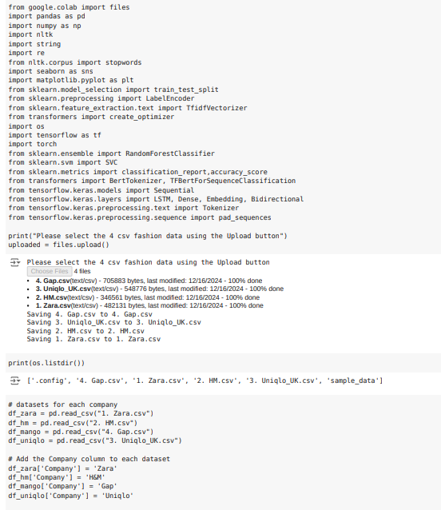

The data collection phase of this project involved gathering social media interaction data from four leading fashion brands: Zara, H&M, Gap, and Uniqlo. These brands were chosen for their significant online presence and diverse customer base, which provided a rich dataset for analysis. The primary source of data was Twitter, a platform widely used for consumer-brand interactions. Each dataset was extracted in CSV format and contained essential attributes necessary for analysis and modelling.

Key attributes in the datasets include –

* ***Tweet Content –*** Textual data representing consumer feedback, brand mentions, hashtags, and promotional content. These texts provided insights into consumer sentiment, preferences, and trends.
* ***Engagement Metrics –*** Data on likes, retweets, and replies. These metrics quantified user interaction and engagement levels for each tweet.
* ***Media Attachments –*** Information on the presence of images, videos, or GIFs. Media content is known to impact engagement rates significantly.
* ***Temporal Data –*** Timestamp details for each post. These allowed for temporal analysis to identify trends over specific periods.
* ***Brand Identifier –*** A categorical variable denoting the brand associated with each tweet, enabling cross-comparisons among brands.

The collection process utilized Python libraries such as Pandas and Numpy for handling large datasets. The data was retrieved using APIs and pre-processed to remove duplicates, ensuring consistency and reliability. Each brand’s dataset was enriched with metadata, including post length, sentiment scores (computed during preprocessing), and media type counts.

To provide a holistic understanding, the datasets were combined into a unified structure. This consolidation facilitated comparative analysis across brands, allowing for the identification of universal patterns and brand-specific trends. For instance, Zara and H&M were observed to focus on visually appealing campaigns with higher media usage, while Gap and Uniqlo leaned towards text-heavy, informational tweets.

Data collection also accounted for the following –

* ***Coverage Period –*** Tweets from 2017 to 2023 were included to capture evolving consumer behaviour and market dynamics over time.
* ***Data Validation –*** The integrity of the data was ensured through checks for missing values, inconsistencies in timestamps, and erroneous entries. Any anomalies were resolved or excluded from the dataset.
* ***Diversity of Features –*** Features such as hashtags, replies, and post types were included to ensure a comprehensive representation of social media activity.

## Data Preprocessing

Effective preprocessing is the cornerstone of high-quality predictive analytics. For this project, preprocessing ensured the integrity, consistency, and relevance of data, enhancing the accuracy of machine learning models.

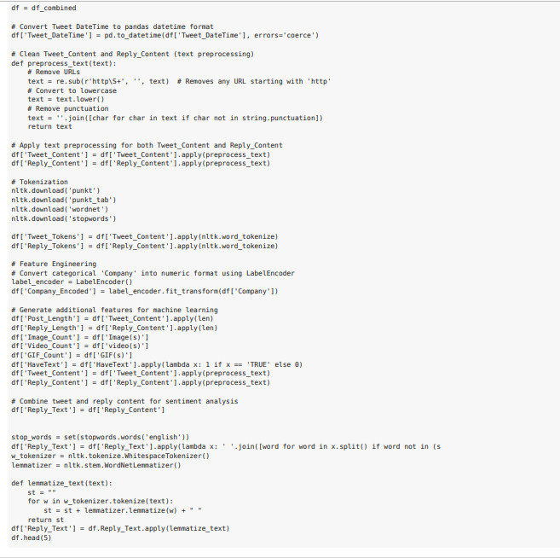

The following steps were implemented systematically –

**Text Cleaning**

Social media data often contains extraneous elements such as URLs, emojis, and special characters, which can introduce noise. Using Python libraries like NLTK and Text Blob, the textual data underwent rigorous cleaning to retain only meaningful content. The process include –

* ***URL Removal –*** Extracted and removed all hyperlinks using regular expressions.
* ***Character Normalization –*** Converted text to lowercase to ensure uniformity.
* ***Emoji and Punctuation Stripping –*** Eliminated emojis and unnecessary punctuation marks.
* ***Stopwords Removal –*** Removed commonly used words (e.g., “and,” “the,” “is”) that do not contribute to sentiment or semantic analysis.

**Tokenization and Lemmatization**

Text was tokenized into individual words, enabling word-level analysis. Lemmatization reduced words to their base forms (e.g., “running” to “run”), ensuring semantic consistency. This reduced redundancy, lowering the feature space dimensionality and enhancing model efficiency. A histogram of word frequencies before and after preprocessing revealed reduced word variations, indicating the success of tokenization and lemmatization in standardizing vocabulary.

**Feature Engineering**

Feature engineering extracted relevant attributes, converting raw data into structured insights.

* ***Length Analysis –*** Analysed tweet lengths (character counts) and categorized them as “short,” “medium,” or “long.” Longer tweets often exhibited more engagement due to richer content.
* ***Media Presence –*** Encoded the inclusion of images, videos, or GIFs as binary variables. Graphical analysis revealed a positive correlation between media-rich posts and higher engagement rates.
* ***Temporal Features –*** Extracted time-based attributes, such as posting hours, weekdays, and months, to analyse posting patterns. Heatmaps of engagement activity over time highlighted peak posting hours for each brand.

**Encoding Categorical Variables**

Non-numeric variables, such as brand names and media types, were encoded using Label Encoder. This conversion allowed machine learning algorithms to process categorical data effectively. For example, brand identifiers (e.g., Zara, H&M) were represented as integers.

**Handling Missing Values**

Missing data points in fields like hashtags and media usage were addressed using imputation techniques. Median values were substituted for numeric fields, while mode imputation filled missing categorical entries. In cases where imputation could compromise data integrity, such entries were excluded.

**Text Vectorization**

To convert text data into numerical format for model compatibility, two vectorization techniques were employed which are –

* ***TF-IDF (Term Frequency-Inverse Document Frequency) –*** Highlighted significant terms by measuring their importance relative to document frequency.
* ***Word Embeddings –*** BERT-based embeddings captured contextual relationships between words, outperforming traditional methods in semantic analysis tasks.

**Outlier Detection and Removal**

Outliers in numeric features like engagement metrics (e.g., unusually high retweets) were identified using z-scores and boxplots. Extreme outliers, likely resulting from anomalies or bot activity, were excluded. This minimized skewness, ensuring that analyses reflected typical user behaviour.

**Data Standardization and Scaling**

Numeric features were standardized to a mean of 0 and a standard deviation of 1, ensuring equal importance across variables. For certain features like engagement metrics, Min-Max Scaling normalized values to a 0–1 range, maintaining comparability.

## Interpretation of graphical trends

### Distribution of Numerical Features

Histogram for features like post length, likes count, replies count and retweets count revealed skewed distributions, indicating a few posts with disproportionately high engagement metrics. Kernel Density Estimates (KDE) overlaid on histograms provided additional insights into data smoothness. This analysis confirmed the need for normalization during preprocessing to mitigate biases caused by outliers.

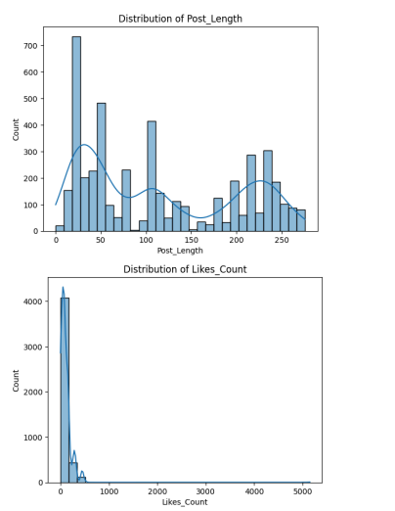 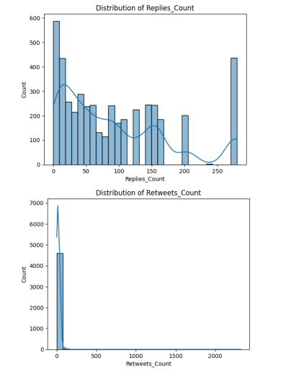

Figure 1 - Distribution by Numerical Features

### Tweet Distribution by company

A bar chart showed the number of tweets from each company, highlighting Zara as the most active on Twitter, followed by H&M, Uniqlo, and Gap. This suggested differences in engagement strategies and the volume of consumer interactions.

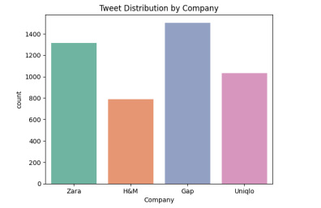

Figure 2 - Tweet Distribution by Company

### Tweets with Text vs Without

A count plot compared tweets containing textual content against those without. Text-inclusive tweets were overwhelmingly more frequent, emphasizing their critical role in sentiment and content analysis.

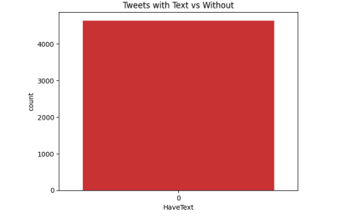

Figure 3 - Tweets with Text vs Without Text

### Correlation Matrix

A heatmap visualized correlations between features like likes count, replies count and retweets count. Strong positive correlations between these metrics suggested interconnected engagement patterns, which were considered for feature selection during modelling.

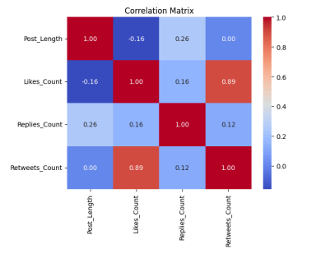

Figure 4 - Correlation Matrix

### Top 10 Used Hashtags

A bar chart of the most frequently used hashtags revealed brand-specific trends and consumer interests. Hashtags like #NewCollection and #Discounts were highly popular, reflecting promotional campaigns and seasonal spikes in consumer activity.

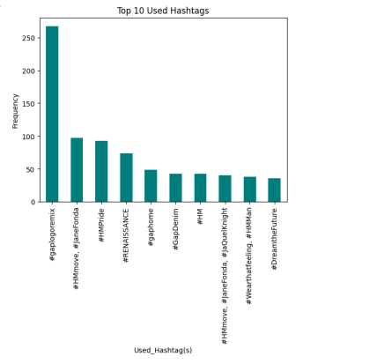

Figure 5 - Top 10 used Hashtags

### Media Usage in Tweets

A bar chart of media types (images, videos, GIFs) illustrated that images dominated tweet content, followed by videos. GIFs were least used but showed niche engagement opportunities.

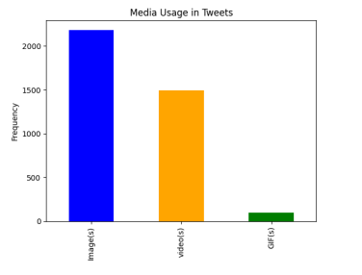

Figure 6 - Media Usage in Tweets

### Engagement by Media Type

Grouped bar charts compared engagement levels (likes, replies, retweets) across media types. Tweets with images consistently outperformed others, reinforcing the importance of visual content in social media strategies.

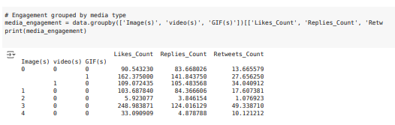

### Likes Over Time

A time-series plot depicted cumulative likes over the dataset's coverage period. Peaks corresponded to promotional campaigns or seasonal events, offering actionable insights for marketing strategies.

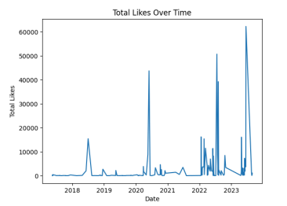

Figure 7 - Total Likes Over Time

### Likes by Hour of the Day

A boxplot revealed hourly engagement trends, with late evenings showing the highest median likes. This insight informed optimal posting times for maximizing visibility and interactions.

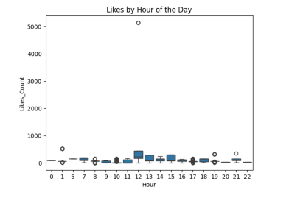

Figure 8 - Likes by Hour of the Day

# Model Selection and Development

Model selection and development form the backbone of this predictive analytics project, providing the framework to analyse consumer behaviour and forecast market trends effectively. With the diverse and dynamic nature of social media data, the study required selecting and customizing machine learning models to capture non-linear relationships, temporal patterns, and textual insights. The following outlines the criteria, approaches, and processes for selecting and developing these models.

## Criteria for Model Selection

The selection of models was guided by specific requirements of the dataset and the nature of predictions. Key criteria included –

* ***Capability to Handle Textual Data –*** Given the predominance of tweet content in the dataset, models with robust natural language processing (NLP) capabilities, such as BERT, were prioritized.
* ***Temporal Dependency Modelling –*** To capture trends and patterns over time, models like LSTM, which specialize in sequential data, were essential.
* ***Scalability –*** The models needed to scale well with large datasets containing thousands of entries across multiple brands.
* ***Interpretability vs. Complexity –*** While advanced models like transformers excel in accuracy, simpler models such as Random Forest offered interpretability, crucial for actionable insights.

Based on these criteria, the models selected include –

* Random Forest – For its ability to handle structured data and feature importance analysis.
* Support Vector Machines (SVM) – Effective for high-dimensional data and text classification.
* Long Short-Term Memory (LSTM) – Designed for capturing sequential and temporal dependencies.
* BERT – A state-of-the-art transformer model for deep NLP tasks.

## Model Development

### Random Forest

Random Forest, an ensemble learning technique, was chosen for its robustness in handling structured datasets. Its ability to combine multiple decision trees through bagging (Bootstrap Aggregating) ensured high accuracy and low variance.

**Development Process**

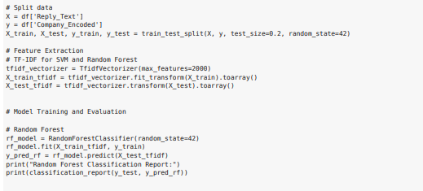

The Random Forest model was trained on features such as engagement metrics (likes, retweets, replies), temporal data, and media presence. Hyperparameters like the number of trees and maximum depth were tuned using grid search to balance performance and computational efficiency.

**Feature Importance**

The model’s inherent feature importance metric provided insights into which variables significantly influenced engagement, such as the presence of images or posting time.

**Strengths**

Random Forest performed exceptionally well in classifying tweets based on engagement levels and predicting categorical variables, such as media usage patterns.

**Challenges**

While effective for structured data, the model struggled with unstructured textual content, necessitating supplementary NLP models.

### Support Vector Machines (SVM)

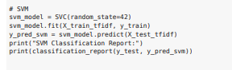

SVMs were employed to classify tweets into categories such as sentiment (positive, neutral, negative) and engagement levels. Their capacity for high-dimensional data made them ideal for text analysis tasks.

**Kernel Selection**

To handle the non-linear relationships in the dataset, the radial basis function (RBF) kernel was used. This kernel mapped data to a higher-dimensional space, improving classification accuracy.

**Text Vectorization**

TF-IDF (Term Frequency-Inverse Document Frequency) was utilized to convert tweet content into numerical vectors, capturing the relative importance of words across the dataset.

**Model Training**

A balanced dataset ensured that the model didn’t Favor any sentiment category disproportionately. Cross-validation techniques were applied to prevent overfitting.

**Outcomes**

SVMs delivered precise sentiment classification but were computationally intensive for large datasets, requiring optimization techniques like dimensionality reduction.

### Long Short-Term Memory (LTSM)

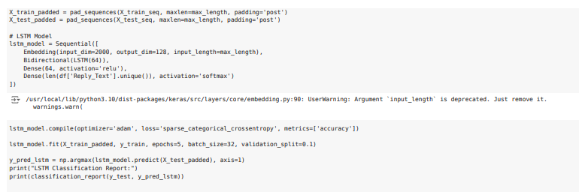

LSTMs were pivotal in analysing temporal trends in engagement metrics. As a type of recurrent neural network (RNN), LSTMs excel at retaining long-term dependencies, addressing the vanishing gradient problem common in traditional RNNs.

**Temporal Feature Engineering**

Sequential features such as time of post, cumulative engagement over weeks, and lagged variables were fed into the LSTM model. Sliding windows were applied to segment data into manageable sequences.

**Architecture Design**

The LSTM model consisted of multiple layers, including dropout layers to reduce overfitting. Activation functions like ReLU were used for intermediate layers, with a sigmoid function for the final output.

**Hyperparameter Tuning**

Parameters such as the number of hidden units, batch size, and learning rate were optimized using random search.

**Performance**

LSTMs captured engagement peaks and seasonal patterns effectively but required significant computational resources, especially for long input sequences.

### BERT (Bidirectional Encoder Representations from Transformers)

BERT, a transformer-based model, was the cornerstone for natural language understanding tasks in the project. Its ability to understand context by considering words in both directions (bidirectional) made it indispensable for sentiment and intent analysis.

**Pretrained Model Usage**

A pretrained BERT model was fine-tuned on the tweet dataset, leveraging transfer learning to save time and resources.

**Tokenization**

The BERT tokenizer split text into sub words, enabling the model to handle out-of-vocabulary words effectively. Special tokens ([CLS] and [SEP]) were added to denote sentence boundaries.

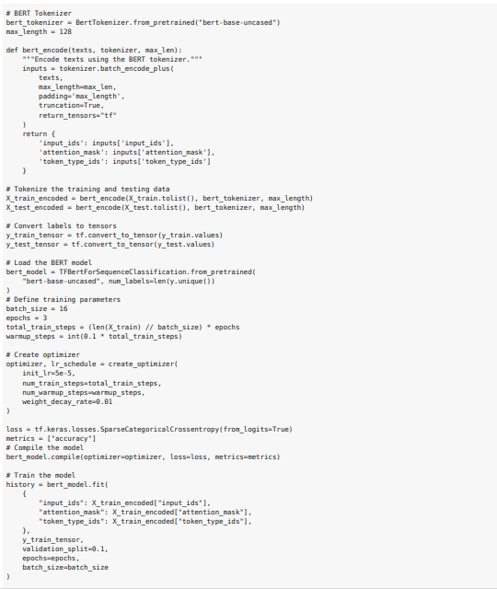

**Fine-Tuning**

The model was fine-tuned on downstream tasks such as sentiment classification and keyword extraction. The Adam optimizer with a learning rate scheduler was used to enhance convergence.

**Strengths**

BERT excelled in understanding nuanced sentiments and identifying latent themes within tweets.

**Challenges**

High computational demands and a steep learning curve for implementation were notable drawbacks.

## Model Integration

To harness the strengths of individual models, an integrated approach was adopted.

**Ensemble Learning**

Combining predictions from Random Forest, SVM, and LSTM models improved overall accuracy. Weighted averages were used to assign importance based on each model’s performance on validation data.

**Hybrid Models**

LSTM outputs were fed into BERT for enhanced sentiment analysis, enabling context-aware temporal predictions.

## Evaluation Metrics

The models were evaluated on metrics tailored to their respective tasks:

**Classification Metrics**

For models like Random Forest and SVM, precision, recall, and F1-score assessed their ability to categorize tweets accurately. Confusion matrices provided a detailed breakdown of misclassifications.

**Regression Metrics**

For LSTM and hybrid models, mean squared error (MSE) and R-squared values measured their accuracy in predicting engagement metrics.

**Text Analysis Metrics**

For BERT, metrics such as BLEU scores and accuracy in sentiment classification highlighted its effectiveness.

# Discussion and results

This section synthesizes the insights derived from applying predictive analytics to social media data, evaluating the effectiveness of models, and interpreting their results. The findings offer a comprehensive understanding of consumer behaviour and engagement patterns, highlighting how advanced machine learning methods enable accurate predictions.

## Model Performance Analysis

### Random Forest

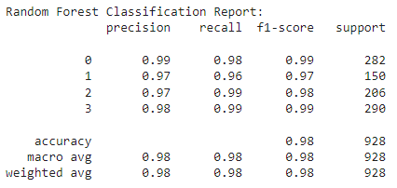

The Random Forest model demonstrated strong predictive capabilities, especially in structured data tasks such as predicting tweet engagement levels. By using features such as media type, time of posting, and engagement metrics, the model achieved high classification accuracy.

* ***Feature Importance –*** Random Forest’s ability to rank features highlighted the importance of media type (images, videos) and post timing. Tweets with media consistently received higher engagement.
* ***Strengths –*** Its interpretability was a key advantage, enabling actionable insights for marketing strategies. Brands could identify the most impactful variables driving engagement.
* ***Limitations –*** While effective for structured data, Random Forest struggled with unstructured text, requiring supplementary NLP techniques for holistic analysis.

### Support Vector Machine

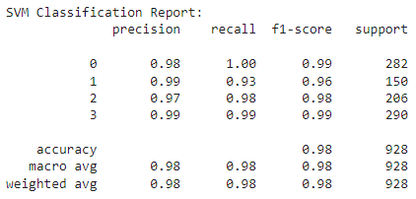

SVM excelled in sentiment classification, effectively distinguishing between positive, neutral, and negative sentiments in tweets. The use of the radial basis function (RBF) kernel improved its performance on non-linear data.

* ***Strengths –*** SVM provided precise sentiment analysis, making it a valuable tool for gauging consumer feedback. Its performance in text vectorization tasks using TF-IDF ensured accurate word-weighting for classification.
* ***Challenges –*** The computational complexity of SVM limited its scalability, especially when dealing with high-dimensional datasets or large text corpora.

### Long Short-Term Memory (LTSM)

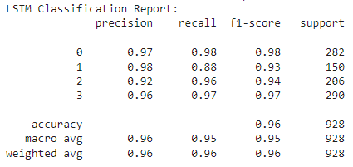

LSTM models excelled at capturing temporal dependencies in sequential data, making them ideal for analysing engagement trends over time. By incorporating features such as cumulative engagement and lagged variables, the model accurately forecasted future interactions.

* ***Strengths –*** LSTM’s architecture enabled it to retain long-term dependencies, effectively identifying seasonal engagement peaks and campaign impacts.
* ***Limitations –*** Training the model required significant computational resources, and overfitting was mitigated using techniques like dropout and early stopping.

### Bidirectional Encoder Representations from Transformers (BERT)

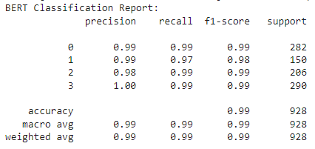

BERT emerged as the most effective model for natural language processing tasks, excelling in sentiment and intent analysis. Its bidirectional attention mechanism captured nuanced semantic relationships, offering unparalleled accuracy.

* ***Strengths*** *–* BERT excelled in understanding context, identifying subtle sentiment shifts, and extracting actionable insights from tweet content. It was particularly useful for detecting consumer intent and preferences.
* ***Challenges*** *–* The model’s computational intensity posed challenges, necessitating cloud-based resources for efficient training.

## Comparative Evaluation

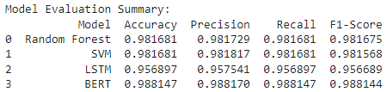

Each model addressed specific facets of the dataset, underscoring the importance of model diversity in predictive analytics. Random Forest was ideal for feature-based analysis, offering interpretability and actionable insights. SVM provided robust sentiment classification, although it required significant preprocessing. LSTM captured time-dependent engagement patterns, enabling trend analysis and forecasting. BERT outperformed in textual analysis, identifying nuanced consumer sentiment and intent. Overall, a hybrid approach combining these models could optimize performance by leveraging their respective strengths. For instance, Random Forest and BERT could collaborate to analyse structured and unstructured data simultaneously.

## Engagement Insights

**Media Impact on Engagement**

Data visualizations revealed that tweets with media (images or videos) consistently outperformed text-only posts in terms of likes, retweets, and replies. Random Forest confirmed this finding, ranking media presence as the most influential feature for predicting engagement.

**Temporal Trends**

Heatmaps and time-series analyses showed that tweets posted during late evenings or weekends received the highest engagement. LSTM effectively captured these patterns, providing brands with optimal posting schedules for maximizing visibility.

**Sentiments Trends**

SVM and BERT highlighted a predominance of positive sentiment in tweets, correlating with higher engagement rates. Negative sentiments, while less frequent, often indicated actionable feedback, such as dissatisfaction with services or products.

## Challenges Addressed

**Overfitting in Complex Models**

Advanced models like LSTM and BERT were prone to overfitting due to their complexity. Techniques such as dropout layers, early stopping, and data augmentation mitigated this issue, improving generalization.

**Data Imbalance**

Certain sentiment categories (e.g., negative tweets) were underrepresented. Synthetic minority oversampling techniques (SMOTE) addressed this imbalance, enhancing model fairness.

**Computational Resource Limitations**

Training deep learning models required substantial computational power. Cloud-based GPUs and distributed training frameworks enabled efficient processing, reducing training time.

## Key findings

**Recommendation for Brands**

* ***Media Strategies –*** Incorporate images and videos in social media campaigns to boost engagement.
* ***Timing Strategies –*** Focus on late evening and weekend posts to align with peak user activity.
* ***Feedback Monitoring –*** Leverage sentiment analysis to identify and address consumer concerns promptly.

**Model-Specific Insights**

Random Forest provided interpretable insights into key engagement drivers. BERT’s NLP capabilities identified latent consumer preferences and emerging trends. LSTM enabled temporal predictions, supporting strategic planning for seasonal campaigns.

**Implications for Future Research**

The study underscores the potential of predictive analytics in transforming social media marketing strategies. However, several areas warrant further exploration –

* ***Real-Time Analytics –*** Future models could integrate real-time data streams for dynamic predictions.
* ***Hybrid Models –*** Combining models like BERT and LSTM could optimize both textual and temporal analyses.
* ***Explainable AI –*** Enhancing model interpretability could build trust and facilitate stakeholder buy-in.

# Conclusion

This study demonstrates the transformative potential of predictive analytics in social media, highlighting its role in forecasting consumer behaviour and uncovering market trends. By analysing data from leading fashion brands such as Zara, H&M, Gap, and Uniqlo, the study illustrates how machine learning models can decode vast and complex datasets, offering actionable insights to refine marketing strategies. The findings emphasize the complementary strengths of diverse models: Random Forest for its interpretability and feature analysis, SVM for precise sentiment classification, LSTM for capturing temporal dependencies, and BERT for its advanced NLP capabilities. Together, these models provide a holistic understanding of consumer interactions, enabling brands to optimize engagement strategies effectively. Key insights include the significant impact of media-enriched content on user engagement, the influence of posting times on visibility, and the value of sentiment analysis in identifying consumer preferences and concerns. These insights empower businesses to tailor their social media campaigns, enhancing their reach and impact. Despite the success, challenges such as overfitting, data imbalance, and computational demands underscore the need for continuous refinement. Future research should explore real-time analytics, hybrid models, and explainable AI to address these limitations and further improve forecasting precision. In conclusion, this study bridges the gap between raw social media data and actionable insights, demonstrating how predictive analytics can drive data-informed decision-making and elevate digital marketing strategies in an increasingly connected world.

# References

Adelani, F. A. (2024). Theoretical Frameworks for the Role of AI and Machine Learning in Water Cybersecurity: Insights from African and US applications. *Computer Science & IT Research Journal, 5*(3), 681-692. https://doi.org/10.51594/csitrj.v5i3.928

Adeoye, O. B. (2024). Fintech, Taxation and Regulatory Compliance: Navigating the New Financial Landscape. *Finance & Accounting Research Journal, 6*(3), 320-330. https://doi.org/10.51594/farj.v6i3.858

Alaparthi, S. (2021). BERT: a sentiment analysis odyssey. *Journal of Marketing Analytics, 9*, 118-126. https://doi.org/10.1057/s41270-021-00109-8

Aldoseri, A. (2023). Re-Thinking Data Strategy and Integration for Artificial Intelligence: Concepts, Opportunities, and Challenges. *Applied Sciences in MDPI, 13*(12). https://doi.org/10.3390/app13127082

Alizadeh, H. (2023). Evaluation of consumer behavior prediction based on artificial intelligence in marketing. *The 15th National Conference on Management and Human Sciences Research.* Iran: Oxford Cert Universal. Retrieved from https://civilica.com/doc/1815725/

Anaba, D. C. (2024). Digital transformation in oil and gas production: Enhancing efficiency and reducing costs. *International Journal of Management & Entrepreneurship Research, 6*(7), 2153-2161. https://doi.org/10.51594/ijmer.v6i7.1263

Arinze, C. A. (2024). Evaluating the Integration of Advanced IT Solutions for Emission Reduction in the Oil and Gas Sector. *Engineering Science & Technology Journal , 5*(3), 639-652. https://doi.org/10.51594/estj.v5i3.862

Atobatele, F. A. (2024). Navigating multilingual identities: The role of languages in shaping social belonging and political participation. *International Journal of Applied Research in Social Sciences, 6*(5), 828-843. https://doi.org/10.51594/ijarss.v6i5.1105

Bajpai, A. (2023). A survey on machine learning techniques used in social media data analysis. *Recent Advances in Sciences, Engineering, Information and Technology and Management, 27822*(1). https://doi.org/10.1063/5.0154568

Bin, S. (2023). Social Network Emotional Marketing Influence Model of Consumers’ Purchase Behavior. *Sustainability in MDPI, 15*(6), 5001. https://doi.org/10.3390/su15065001

Cai, Y. (2024). Prediction of After-Sales Behavior in E-Commerce Using Machine Learning Models. *Open Journal of Statistics, 14*(6), 757-774. https://doi.org/10.4236/ojs.2024.146035

Chakraborty, C. (2021). Economic Growth and Trade-related Variables: An Empirical Study Using Indian Data. In R. C. Das, *Global Tariff War: Economic, Political and Social Implications* (pp. 141-152). Emerald Publishing Limited.

Chaubey, G. (2022). Customer purchasing behavior prediction using machine learning classification techniques. *Journal of Ambient Intelligence and Humanized Computing, 14*, 16133-16157. https://doi.org/10.1007/s12652-022-03837-6

Chaudhary, K. (2021). Machine learning-based mathematical modelling for prediction of social media consumer behavior using big data analytics. *Journal of Big Data, 8*(73). https://doi.org/10.1186/s40537-021-00466-2

Chugh, V. (2023, May 30). *Python pandas tutorial: The ultimate guide for beginners*. Retrieved from DataCamp: https://www.datacamp.com/tutorial/pandas

Donald, O. (2024). Reviewing advancements in privacy-enhancing technologies for big data analytics in an era of increased surveillance. *World Journal of Advanced Engineering Technology and Sciences, 11*(1), 294-300. https://doi.org/10.30574/wjaets.2024.11.1.0060

Doorn, B. v. (2018, April 26). *GDPR compliance: how data analytics can help*. Retrieved from EY: https://www.ey.com/en_gl/insights/trust/gdpr-compliance-how-data-analytics-can-help

Duong, H.-T. (2021). A review: preprocessing techniques and data augmentation for sentiment analysis. *Computational Social Networks, 8*(1). https://doi.org/10.1186/s40649-020-00080-x

Ekemezie, I. O. (2024). The role of HR in environmental sustainability initiatives within the oil and gas sector. *World Journal of Advanced Engineering Technology and Sciences, 11*(1), 345-364. https://doi.org/10.30574/wjaets.2024.11.1.0059

Farayola, O. (2024). Advancements in predictive analytics: A philosophical and practical overview. *World Journal of Advanced Research and Reviews, 21*(3), 240-252. https://doi.org/10.30574/wjarr.2024.21.3.2706

Fildes, R. (2022). Retail forecasting: Research and practice. *International Journal of Forecasting, 38*(4), 1283-1318. https://doi.org/10.1016/j.ijforecast.2019.06.004

Giri, C. (2022). Deep Learning for Demand Forecasting in the Fashion and Apparel Retail Industry. *Forecasting in MDPI, 4*(2), 565-581. https://doi.org/10.3390/forecast4020031

Hamli, S. S. (2023). Factors Influencing Consumer Behavior towards Online Shopping in Saudi Arabia Amid COVID-19: Implications for E-Businesses Post Pandemic. *Journal of Risk and Financial Management, 16*(1), 36. https://doi.org/10.3390/jrfm16010036

Han, k. X. (2020). Application of Support Vector Machine (SVM) in the Sentiment Analysis of Twitter DataSet. *Applied Sciences in MDPI, 10*(3), 1125. https://doi.org/10.3390/app10031125

Hickins, M. (2023, February 24). *How Data Analytics Informs the Fashion Industry*. Retrieved from Oracle: https://www.oracle.com/retail/fashion/fashion-analytics/

Ikumapayi, O. M. (2022). A study on AI and ICT for Sustainable Manufacturing. *3rd African International Conference on Industrial Engineering and Operations Management.* Nsukka, Nigeria: IEOM Society. https://doi.org/10.46254/AF03.20220259

Islam, M. S. (2024). Challenges and future in deep learning for sentiment analysis: a comprehensive review and a proposed novel hybrid approach. *Artificial Intelligence Review, 57*(62). https://doi.org/10.1007/s10462-023-10651-9

Iyelolu, T. V. (2024). Anti-Money Laundering Compliance and Financial Inclusion: A Technical Analysis of Sub-Saharan Africa. *GSC Advanced Research and Reviews, 19*(3), 336-343. https://doi.org/10.30574/gscarr.2024.19.3.0235

Jacks, B. S. (2024). Theoretical frameworks for ICT for development: Impact assessment of telecommunication infrastructure projects in Africa and the U.S. *World Journal of Advanced Research and Reviews, 21*(3), 394-400. https://doi.org/10.30574/wjarr.2024.21.3.0721

Jang, D. (2024, November 13). *Harnessing Support Vector Machines for Advanced Social Media Analytics*. Retrieved from Medium: https://medium.com/@jangdaehan1/harnessing-support-vector-machines-for-advanced-social-media-analytics-c129c0cefcde

Joel, O. (2024). Data-driven strategies for business expansion: Utilizing predictive analytics for enhanced profitability and opportunity identification. *International Journal of Frontiers in Engineering and Technology Research, 6*(2), 71-81. https://doi.org/10.53294/ijfetr.2024.6.2.0035

Johnson, E. (2024). Developing scalable data solutions for small and medium enterprises: Challenges and best practices. *International Journal of Management & Entrepreneurship Research, 6*(6), 1910-1935. https://doi.org/10.51594/ijmer.v6i6.1206

Kapil, A. R. (2024, April 26). *How To Visualize Data Using Python: Learn Visualization Using Pandas, Matplotlib and Seaborn*. Retrieved from Analytix Labs: https://www.analytixlabs.co.in/blog/python-visualization/

Kess-Momoh, A. J. (2024). Developing a conceptual technical framework for ethical AI in procurement with emphasis on legal oversight. *GSC Advanced Research and Reviews, 19*(1), 146-160. https://doi.org/10.30574/gscarr.2024.19.1.0149

Konina, N. Y. (2023). Artificial Intelligence in the Fashion Industry—Reality and Prospects. In E. G. Popkova, *Anti-Crisis Approach to the Provision of the Environmental Sustainability of Economy* (pp. 273-280). Springer.

Lande, O. B. (2024). The role of data visualization in strategic decision making: Case studies from the tech industry. *Computer Science & IT Research Journal, 5*(6), 1374-1390. https://doi.org/10.51594/csitrj.v5i6.1223

Lilhore, U. K. (2021). Hybrid Weighted Random Forests Method for Prediction & Classification . *Journal of Information Technology Management, 13*(2), 245-259. https://doi.org/10.22059/jitm.2021.310062.2607

Lottu, O. (2024). Towards a conceptual framework for ethical AI development in IT systems. *World Journal of Advanced Research and Reviews , 21*(3), 408-415. https://doi.org/10.30574/wjarr.2024.21.3.0735

McFarland, A. (2024, January 16). *10 Best Python Libraries for Natural Language Processing*. Retrieved from Unite: https://www.unite.ai/10-best-python-libraries-for-natural-language-processing/

Mercy, S. (2018). Sustaining Employees and Organizational Productivity through Technological Change in Consumers’ Goods Industry. *DBA Africa Management Review, 8*(1), 1-16.

Mouboua, P. D. (2024). Cross-cultural competence in global HRD: Strategies for developing an inclusive and diverse workforce. *International Journal of Science and Research Archive, 12*(1), 103-113. https://doi.org/10.30574/ijsra.2024.12.1.0765

Mühlhoff, R. (2021). Predictive privacy: towards an applied ethics of data analytics. *Ethics and Information Technology, 23*, 675-690. https://doi.org/10.1007/s10676-021-09606-x

Nwaimo, C. (2024). Forecasting HR expenses: A review of predictive analytics in financial planning for HR. *International Journal of Management & Entrepreneurship Research, 6*(6), 1842-1853. https://doi.org/10.51594/ijmer.v6i6.1169

Obinna, A. J. (2024). Comparative technical analysis of legal and ethical frameworks in AI-enhanced procurement processes. *World Journal of Advanced Research and Reviews, 22*(1), 1415-1430. https://doi.org/10.30574/wjarr.2024.22.1.1241

Odeyemi, O. (2024). Entrepreneurship in Africa: A Review of Growth and Challenges. *International Journal of Management & Entrepreneurship Research, 6*(3), 608-622. https://doi.org/10.51594/ijmer.v6i3.874

Ofodile, O. C. (2024). Digital Banking Regulations: A Comparative Review between Nigeria and the USA. *Finance & Accounting Research Journal , 6*(3), 347-371. https://doi.org/10.51594/farj.v6i3.897

Okafor, A. (2024). Cybersecurity Analytics in Protecting Satellite Telecommunications Networks: A Conceptual Development of Current Trends, Challenges and Strategic Responses. *International Journal of Applied Research in Social Sciences, 6*(3), 254-266. https://doi.org/10.51594/ijarss.v6i3.854

Okogwu, C. (2023). Exploring the Integration of Sustainable Materials in Supply Chain Management for Environmental Impact. *Engineering Science & Technology Journal, 4*(3), 49-65. https://doi.org/10.51594/estj.v4i3.546

Omotoye, G. B. (2024). Navigating global energy markets: A review of economic and policy impacts. *International Journal of Science and Research Archive, 11*(1), 195-203. https://doi.org/10.30574/ijsra.2024.11.1.0029

Onesi-Ozigagun, O. (2024). Leading Digital Transformation in Non-Digital Sectors: A Strategic Review. *International Journal of Management & Entrepreneurship Research, 6*(4), 1157-1175. https://doi.org/10.51594/ijmer.v6i4.1005

Oyewole, A. T. (2024). Human Resource management Strategies for Safety and Risk Management in the Oil and gas Industry: A Review. *International Journal of Management & Entrepreneurship Research, 6*(3), 623-633. https://doi.org/10.51594/ijmer.v6i3.875

Paul, P. O. (2024). Advancing strategic procurement: Enhancing efficiency and cost management in high-stakes environments. *International Journal of Management & Entrepreneurship Research, 6*(7), 2100-2111. https://doi.org/10.51594/ijmer.v6i7.1259

Qi, Y. (2023). Sentiment analysis using Twitter data: a comparative application of lexicon- and machine-learning-based approach. *Social Network Analysis and Mining, 13*(31). https://doi.org/10.1007/s13278-023-01030-x

Raji, M. A. (2024). E-commerce and consumer behavior: A review of AI-powered personalization and market trends. *GSC Advanced Research and Reviews, 18*(3), 66-77. https://doi.org/10.30574/gscarr.2024.18.3.0090

Ramos, L. (2023). Artificial intelligence and sustainability in the fashion industry: a review from 2010 to 2022. *SN Applied Sciences, 5*(387). https://doi.org/10.1007/s42452-023-05587-2

Reuß, F. (2021). Comparison of Long Short-Term Memory Networks and Random Forest for Sentinel-1 Time Series Based Large Scale Crop Classification. *Remote Sensing in MDPI, 13*(24). https://doi.org/10.3390/rs13245000

Samuel, W. U. (2024). Theoretical approaches to data analytics and decision-making in finance: Insights from Africa and the United States. *GSC Advanced Research and Reviews, 18*(3), 343-349. https://doi.org/10.30574/gscarr.2024.18.3.0114

Scott, A. (2024). The role of Blockchain technology in enhancing transparency and trust in green finance markets. *Finance & Accounting Research Journal, 6*(6), 825-850. https://doi.org/10.51594/farj.v6i6.1181

Scutari, M. (2023). *The Pragmatic Programmer for Machine Learning.* India: Chapman and Hall/CRC.

Shadmehr, B. (2023, December 10). *Exploring Seaborn for Statistical Visualization*. Retrieved from Dev Community: https://dev.to/bshadmehr/exploring-seaborn-for-statistical-visualization-287e

Shoetan, P. O. (2024). Transforming Fintech Fraud Detection with Advanced Artificial Intelligence Algorithm. *Finance & Accounting Research Journal, 6*(4), 602-625. https://doi.org/10.51594/farj.v6i4.1036

Sundararaj, V. (2021). A detailed behavioral analysis on consumer and customer changing behavior with respect to social networking sites. *Journal of Retailing and Consumer Services, 58*(2-4). https://doi.org/10.1016/j.jretconser.2020.102190

Talaat, A. S. (2023). Sentiment analysis classification system using hybrid BERT models. *Journal of Big Data, 10*(110). https://doi.org/10.1186/s40537-023-00781-w

Tula, S. T. (2024). AI-Enabled Customer Experience Enhancement in Business. *Computer Science & IT Research Journal, 5*(2), 365-389. https://doi.org/10.51594/csitrj.v5i2.789

Udeh, E. (2024). The integration of artificial intelligence in cybersecurity measures for sustainable finance platforms: An analysis. *Computer Science & IT Research Journal , 5*(6), 1221-1246. https://doi.org/10.51594/csitrj.v5i6.1195

Usman, F. O. (2024). Market Expansion and Competitive Positioning in Satellite Telecommunications: A Review of Analytics Driven Strategies within the Global Landscape. *International Journal of Management & Entrepreneurship Research, 6*(3), 567-581. https://doi.org/10.51594/ijmer.v6i3.845

Yin, Z. (2023). DPG-LSTM: An Enhanced LSTM Framework for Sentiment Analysis in Social Media Text Based on Dependency Parsing and GCN. *Applied Sciences in MDPI, 13*(1), 354. https://doi.org/10.3390/app13010354